Passover 2017
Transfers & Optional Tours
Grand Hotel Palazzo della Fonte

Montitour will be handling airport transfers and all group tours for our Passover guests.
In order to better serve you, please reserve in advance all your transfers and tours. Silvana, will be the contact person for your airport transfers and touring needs. She speaks English fluently See below her contact information. Montitour offers all types of services including group tours (see below) private transfers and private tours anywhere you want.
All payments are made directly to Montitour through Credit Card, PayPal or bank wire transfer.

CONTACT PERSON: SILVANA
Mobile 011-39-373-721-4635
email: passoverfiuggi@montitour.it

AIRPORT TRANSFER RATES
FROM: FIUMICINO AIRPORT (ROME)
TO: GRAND HOTEL PALAZZO DELLA FONTE – FIUGGI
Please click on the following link for all airport transfer information:

http://www.montitour.it/ecommerce/index.php?id_category=12&controller=category&id_lang=1

POMPEII - VESUVIO

Thursday, April 13, 2017
€. 99,00 p.p.
(€. 30,00 entrance fees not included)
depart: 8:00 a.m. - return: 7:30 p.m.
Departure and arrival from hotel in Fiuggi

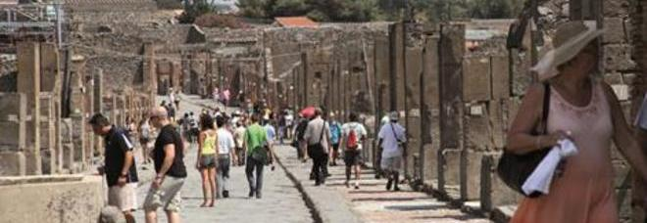

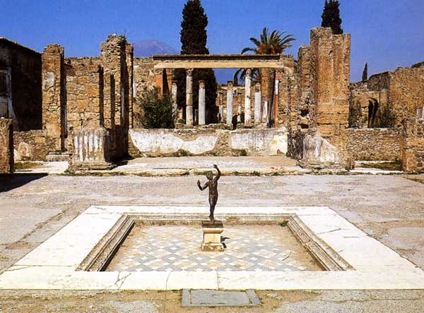
The excavations of Pompeii are extraordinary material evidence of the ancient world, thanks to the state of preservation of the city, which remained practically intact after the eruption of 79 A.D. erased it from the Vesuvian landscape. Pompeii is a unique example of a typical Roman city with its villas, homes, temples, the forum, the theater and spas. Most of the city was brought back to the light with appropriate excavation and thanks to this, it is now possible to reconstruct with certainty the organizational life of the ancient Romans, their uses and their customs. This is a truly amazing place and a must to visit. At the end of the visit, continuing by bus, towards the Vesuvius, the volcano in which, with its eruption, buried the towns of Pompeii and Ercolano. Arriving at the main square, and continuing by foot to the ridge of the crater (approx. 30 minute walk). During the visit you will be accompanied by and expert guide. We advise you to wear suitable and comfortable shoes suited to walk the streets of Pompeii and the paths pf the mountain which reach 1000m above sea level, besides sun glasses, binoculars and your cameras.

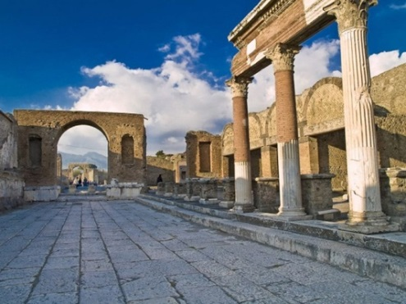

AMALFI COAST

Thursday, April 13, 2017
€. 95,00 p.p.
(€. 20,00 entrance fees not included)
depart: 8:00 a.m. - return: 7:30 p.m.
Departure and arrival from hotel in Fiuggi

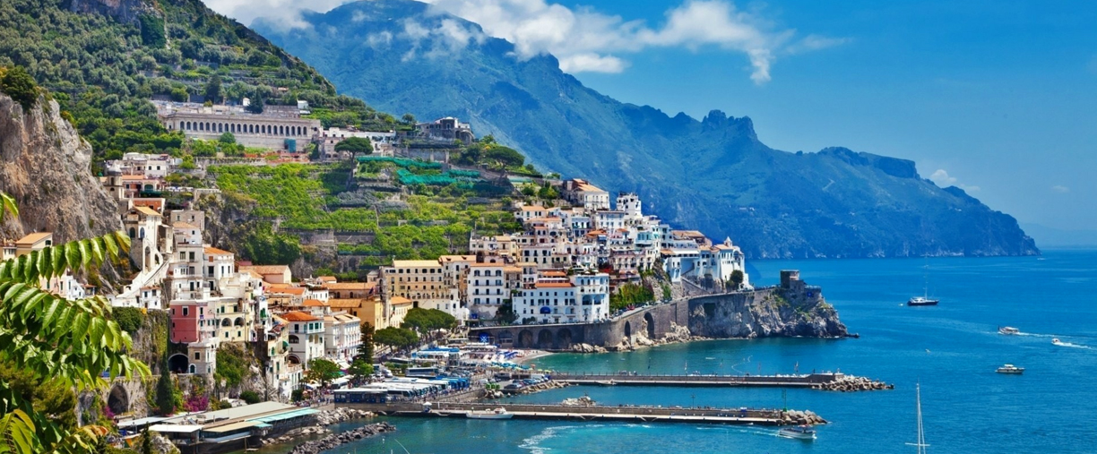

The scenic tour of the beautiful Campania coast line will take you to those wonderful places that inspired the great Caruso and the birthplace of Torquato Tasso. We will go through: Sorrento, Positano, Ravello, Vietri sul Mare, etc. with stops in Conca dei Marini to visit the "Emerald Cave" and Amalfi (the Sant'Andrea Cathedral, an extraordinary example of architecture in the Arab-Norman style).

Meeting with the guide and start the tour of the Amalfi Coast. Panoramic stop at Belvedere "Madonna" (parking space permitting) to admire the village of Positano from above. Crossing the villages of Praiano and Furore. Stop in Conca dei Marini to see the famous Emerald Cave. Continuation to Amalfi, stop and visit the monumental complex of St. Andrew: Paradise Cloister, the Crypt and the Basilica. Continue to Ravello and visit of Villa Rufolo overlooking with its large terrace on the beautiful Costa.

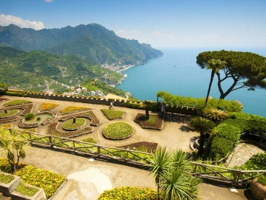
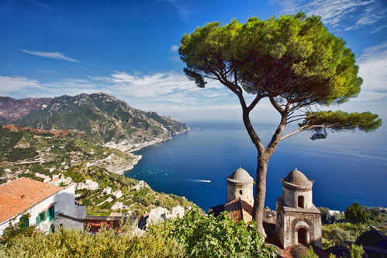
JEWISH ROME AND ROME FOUNTAINS

Friday, April 14, 2017
€. 80,00 p.p.
(including entrance fees)
depart: 8:30 a.m. - return: 4:30 p.m.
Departure and arrival from hotel in Fiuggi
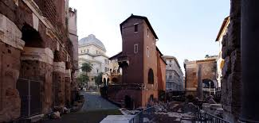
You will discover how the small Jewish community of Rome survived and still thrives after 22 centuries. The “Teatro Marcello” and the “Portico d’Ottavia” are some of the stops on the streets of the Jewish Ghetto, one of the oldest Jewish communities on the western Mediterranean. The main Piazza in the Jewish quarter has been considered the main meeting point for the Jewish people over the ages. At the end of this visit, you will be taken on a walk through the streets of Rome, through the most significant scenic accommodations, including places of ancient memories and solutions of modern town planning. The tour begins at “Piazza Navona” and continues to the “Pantheon”. You will be accompanied to the discovery of famous and fascinating sites: squares, fountains and historical churches. We will cross “Piazza Colonna” and the “Corso”, to reach the Trevi Fountain. How can you not to throw a coin into the water to make a wish? Then a walk up to the Spanish Steps to admire the "Barcaccia" and “Trinità dei Monti”.

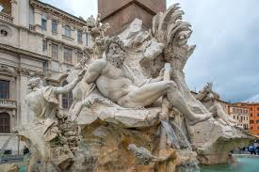
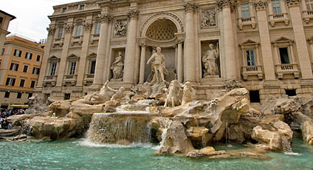

OUTLET CASTEL ROMANO

Friday, April 14, 2017
€. 30,00 p.p.
depart: 9:00 a.m. - return: 4:30 p.m.
Departure and arrival from hotel in Fiuggi

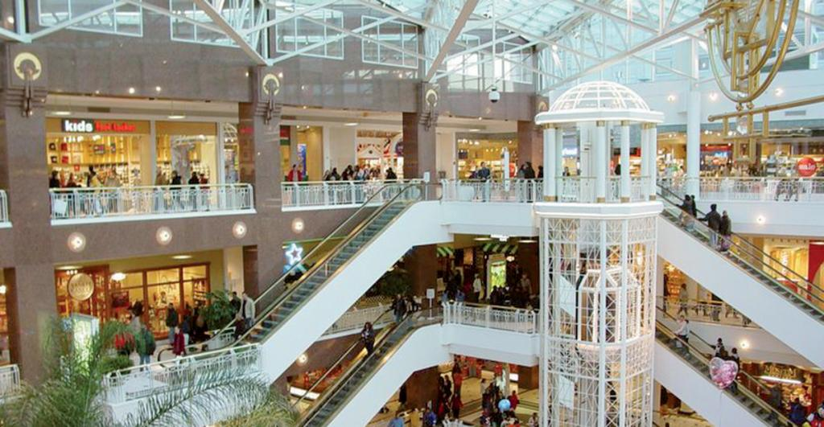

Discover your favourite labels at prices from 30% to 70% off throughout the year. At Castel Romano Designer Outlet there is always something special for everyone: the splendid architectural setting, bars and restaurants and more than 140 shops. You'll find big names including Valentino, Roberto Cavalli and Michael Kors, Versace, sportswear brands such as Nike and Adidas, and many other major fashion brands such as Guess and Diesel.

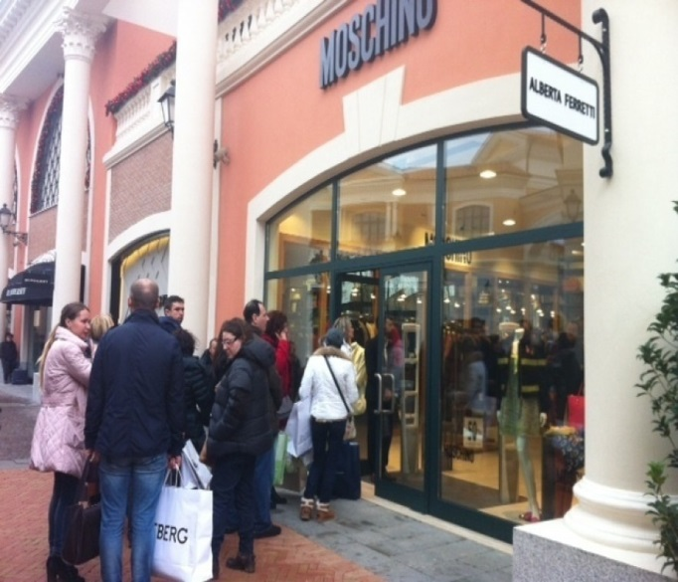
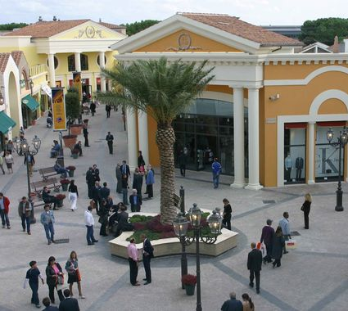

REGGIA DI CASERTA
BORGO DI SAN LEUCIO – MUSEO DELLA SETA

Friday, April 14, 2017
€. 95,00 p.p.
(€. 20,00 entrance fees not included)
depart: 8:00 a.m. - return: 4:30 p.m.
Departure and arrival from hotel in Fiuggi

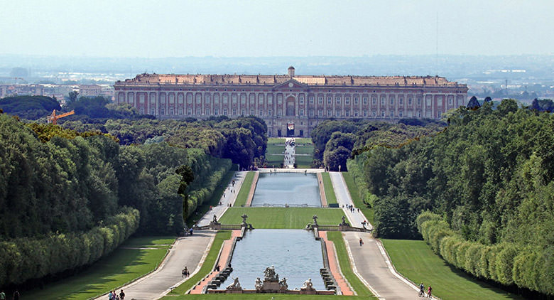
The Royal Palace of Caserta was built in 1752 by Luigi Vanvitelli at the request of the King of Naples, Carlo di Borbone or Charles of Bourbon with the purpose to build it as the fulcrum of the new kingdom of Naples. The intent was to build something that could not only stand up to the Palace of Versailles, but even overcome it in majesty. In 1997 The Royal Palace of Caserta was declared a UNESCO World Heritage Site, along with the complex of San Leucio. The Palace consists of an area of 47,000 m2, five floors and four interior courtyards. It has within it a majestic grand staircase, the Palatine Chapel, the historic building, the theatre of the court and the Picture Gallery. The park and the waterfall, also give the complex a highly elegant and scenic resolution. The visit continues in the village of San Leucio, home of the Silk Museum which includes the school, home of the parish priest, workshops for spinning and twisting silk, the room for weaving and for dyeing, the hall of frames and the Royal apartment. In the early 1800’s the factory was expanded with the construction of the Spinning Mill of Cypresses and in 1823, the Coculliera for the storage and preparation of silk worms waiting for reeling. You will visit the Royal apartment consisting of a series of rooms housing numerous machines and equipment of the era used in the different stages of silk processing and the "House of the Weaver", a typical home of the Luciano worker of the 1800’s. At the end of the tour, you can browse and shop, in several of the village shops.

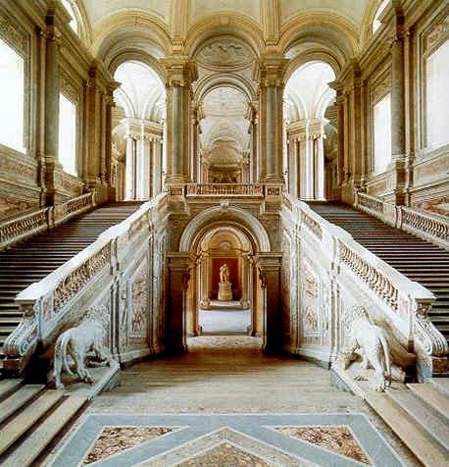
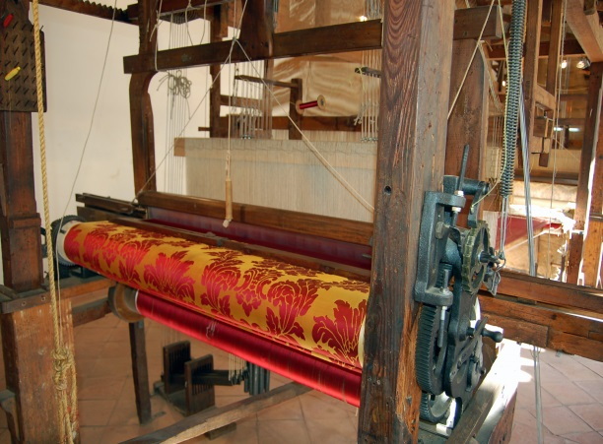

ANCIENT ROME
Colosseum and Roman Forum

Sunday, April 16, 2017
€. 95,00 p.p.
(€. 20,00 entrance fees not included)
depart: 8:30 a.m. - return: 4:30 p.m.
Departure and arrival from hotel in Fiuggi
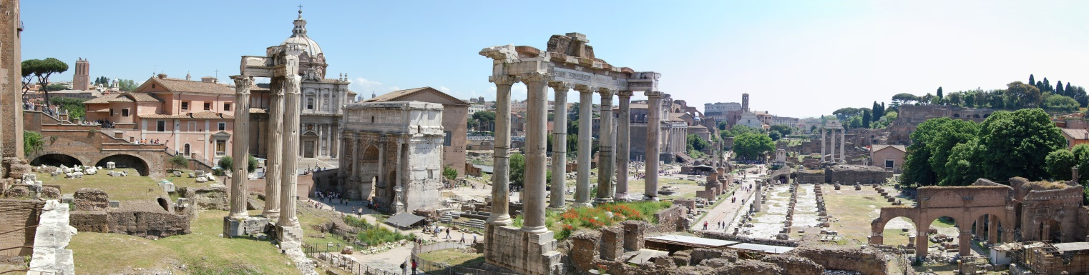
Eternal city, capital of Italy, Roma is also named “caput mundi”. Panoramic tour in the center of the city: Stazione Termini, Piazza della Repubblica, Piazza Venezia, Campidoglio, Bocca della Verità, Circo Massimo, Colosseo.In the morning, the tour includes visiting the Colosseum and the Roman Forum, meeting with the guide outside the monument and an initial explanation of the Valley of the Colosseum and the archaeological center. The course is aimed at identifying the main aspects of public life in the heart of the ancient city, from the age of the directing Empire. The careful analysis of the buildings will reveal the functions and all the activities that took place there: the Colosseum, the monumental setting of spectacular fights between gladiators and fairs; the Roman Forum, the center of judicial, commercial, political and sacral.

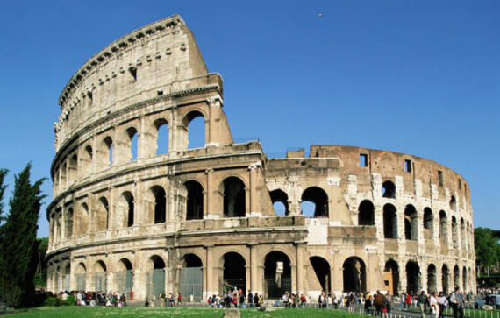
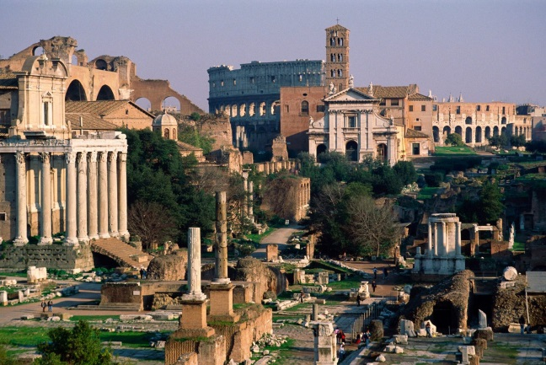

TIVOLI
VILLA D’ESTE AND VILLA ADRIANA

Sunday, April 16, 2017
€. 95,00 p.p.
(€. 20,00 entrance fees not included)
depart: 8:30 a.m. - return: 4:30 p.m.
Departure and arrival from hotel in Fiuggi

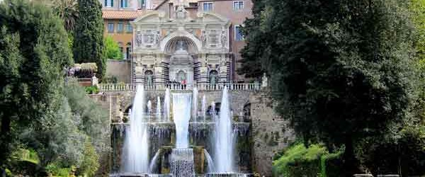

The excursion includes a visit to Villa D'Este, a mansion built upon the request of Cardinal Ippolito II D'Este. The life in this villa was a very active one. In the mid 1500’s, it was a destination for many famous people. It has some beautiful frescoed halls, but the main attraction consists of it's beautiful and original gardens with numerous fountains of incomparable beauty and majesty. Among these, the Fontana dell'Organo, La Rometta, and il Viale delle Cento Fontane, the pathway with the one hundred fountains and much more. Upon finishing the tour, transfer by bus, to Villa Adriana.
The Emperor Hadrian built this country villa for himself and his court, and it bears unique testimony to the grandeur and architectural and decorative characteristics of the period. Today it exists as an immense park, extending over 80 hectares and dotted with several Roman ruins as well as spas and houses from the 1700s and all set in an environment charged with ancient fascination. The grounds also contain the "Teatro Marittimo", an artificial island which was a private residence of the Emperor as well as other interesting locations such as "Canopo", a huge rectangular pool encircled by sculptures which recall the Serapeo. Ongoing excavations have brought to light an intricate system of roads which lead to the imperial residence.

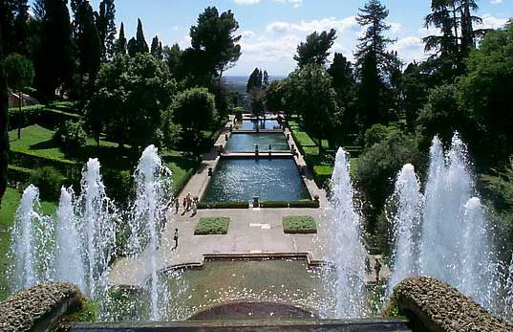
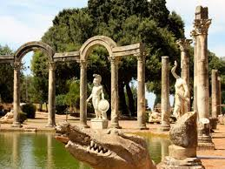

GENERAL TERMS AND CONDITIONS OF PARTECIPATION OF TOURS

The responsibility of the Agency is governed by the following conditions and Legislative Decree 111/95 implementing Directive 90/314 / EC. The conditions described below are an integral part of the travel contract concluded between the participant and the organizing agency. This contract binds the Customer from the moment of final registration of the tours, as well as the Agency.
Registration of the tours will be accepted up to the point where all seats for each coach or minibus have been reserved. In order to adequately prepare visits planned in the archaeological sites, museums and places indicated.

ENTRIES MUST BE RECEIVED BY March 31, 2017

Any bookings made after that date will be accepted subject to seat availability.
The program may be subject to adjustment if unforeseen needs make it necessary. Montitour reserves the right to cancel the tours, at any time prior to departure, with the only obligation of the restitution of the amount collected.
The execution of the excursion is subject to the provision of a minimum number of participants fixed in 35 participants. The registered participant which decides to no longer take part of the tour, must give notice to Montitour by April 1st 2017, obtaining full refund of the amount paid.
No compensation will be granted to those who do not participate in the trip without notice in the manner described above or who give up part of the tour which has already begun. The Agency cannot be held liable for any delays, road interruption, traffic, mechanical failures, strikes, damage or theft, of personal belongings or objects forgotten on the means of transport used, and of possible closure or restoration of museums, monuments, etc.

Montitour is authorized by deliberation n.2079 28/04/87 of Region of Lazio.

