

**Passover 2018**

**Transfers & Optional Tours**

**Grand Hotel Palazzo della Fonte**

Montitour will be handling airport transfers and all group tours for our Passover guests.

In order to better serve you, please reserve in advance all your transfers and tours.

Silvana, will be the contact person for your airport transfers and touring needs. She speaks English fluently.Please see her contact informationbelow. Montitour offers all types of services including group tours private transfers and private tours anywhere you want(see below).

All payments are made directly to Montitour through Credit Card, PayPal or bank wire transfer.

CONTACT PERSON: SILVANA

Mobile 011-39-373-721-4635

email: [passoverfiuggi@montitour.it](mailto:passoverfiuggi@montitour.it)

**AIRPORT TRANSFER RATES**

**FROM: FIUMICINO AIRPORT (ROME)**

**TO: GRAND HOTEL PALAZZO DELLA FONTE – FIUGGI**

Please click on the following link for all airport transfer information:

<http://www.montitour.it/passoverfiuggi>

**POMPEII - VESUVIO**

**Monday, April 2, 2018**

***€. 99,00 p.p.***

*(€. 30,00 entrance fees not included)*

*Depart: 8:00 a.m. - Return: 7:30 p.m.*

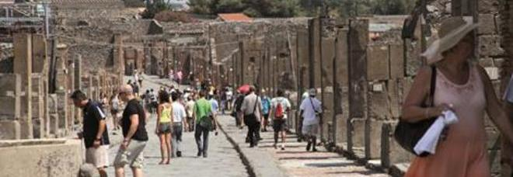Departure and arrival from hotel in Fiuggi

The excavations of Pompeii are extraordinary material evidence of the ancient world, thanks to thestate of preservation of the city which remained practically intact after the eruption of 79 A.D. which erased it from the Vesuvian landscape. Pompeii is a unique example of a typical Roman city with its villas, homes, temples, the forum, the theater and spas.Most of the city was unearthedthrough excavation and it is now possible to reconstruct with certainty the organizational life of the ancient Romans, their uses and their customs. It is a truly amazing placeand a must to visit.At the end of the visit, continuing by bus, towards the Vesuvius, the volcano, with its eruptionburied the towns of Pompeii and Ercolano. Arriving at the main square, wethen continue by foot to the ridge of the crater (approx. 30-minute walk).During the visit, you will be accompanied by an expert guide. Please wear suitable and comfortable shoes suited to walk the streets of Pompeii and the paths of the mountain which reach 1000m above sea level. We suggest bringing sun glasses, binoculars and cameras.

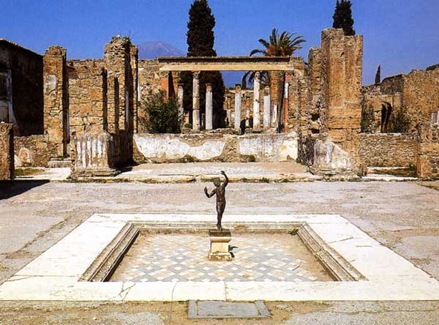

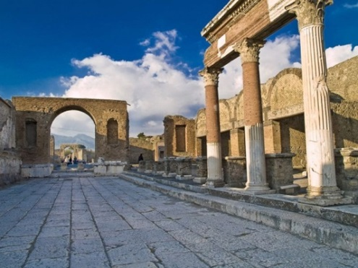

**JEWISH ROME AND ROME FOUNTAINS**

**Monday, April 2, 2018**

***€. 80,00 p.p.***

*(including entrance fees)*

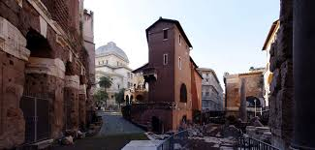*Depart: 8:30 a.m. - Return: 4:30 p.m.*

Departure and arrival from hotel in Fiuggi

You will discover how the small Jewish community of Rome survived and still thrives after 22 centuries. The “Teatro Marcello” and the “Portico d’Ottavia” are some of the stops on the streets of the Jewish Ghetto, one of the oldest Jewish communities on the western Mediterranean. The main Piazza in the Jewish quarter has been considered the main meeting point for the Jewish people over the ages. At the end of this visit, you will be taken on a walk through the streets of Rome, through the most significant scenic accommodations, including places of ancient memories and solutions of modern town planning. The tour begins at “Piazza Navona” and continues to the “Pantheon”. You will be accompanied to the discovery of famous and fascinating sites: squares, fountains and historical churches. We will cross “Piazza Colonna” and the “Corso”, to reach the Trevi Fountain. How can you resist throwing a coin into the water to make a wish? We then walk up to the Spanish Steps to admire the "Barcaccia" and “Trinitàdei Monti”.

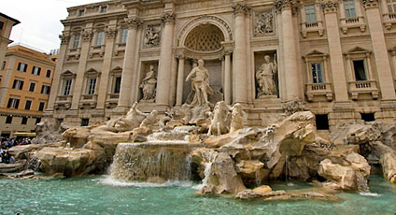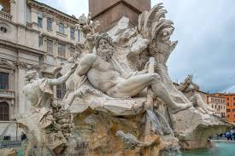

**AMALFI COAST**

**Tuesday, April 3, 2018**

***€. 95,00 p.p.***

*(€. 20.00 entrance fees not included)*

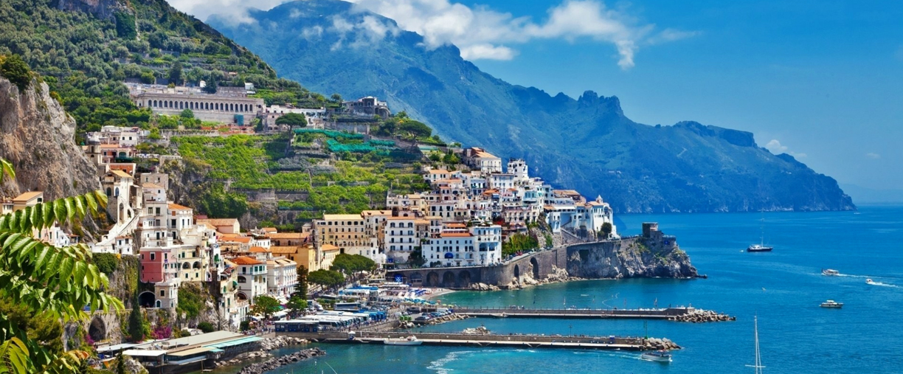*Depart: 8:00 a.m. - Return: 7:30 p.m.*

Departure and arrival from hotel in Fiuggi

Thescenic tour of the beautiful Campania coastline will take you to those wonderful places that inspired the great Caruso and the birthplace of Torquato Tasso. We will go through: Sorrento, Positano, Ravello, Vietrisul Mare, etc. with stops in Conca dei Marini to visit the "Emerald Cave" and Amalfi (the Sant'Andrea Cathedral), an extraordinary example of architecture in the Arab-Norman style).After meeting the guide,we start the tour of the Amalfi Coast. Panoramic stop at Belvedere "Madonna" (parking space permitting) to admire the village of Positano from above. Crossing the villages of Praiano and Furore, we stop in Conca dei Marini to see the famous Emerald Cave. We continuation to Amalfi with a stop at the monumental complex of St. Andrew: Paradise Cloister, the Crypt and the Basilica.We continue to Ravello and visit of Villa Rufolo with its large terrace overlookingthe beautiful Costa.

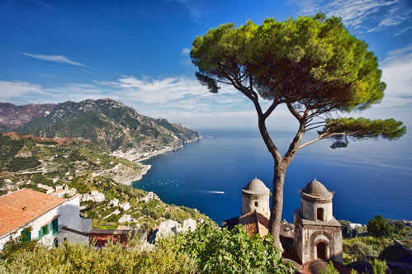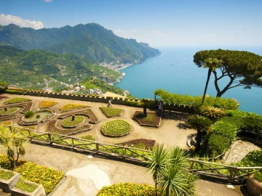

**CAPRI ISLAND**

**Tuesday, April 3, 2018**

***€. 269,00 p.p.***

*(€. 30.00 entrance fees not included)*

*Depart: 6:30 a.m. - Return: 9:00 p.m.*

Departure and arrival from hotel in Fiuggi

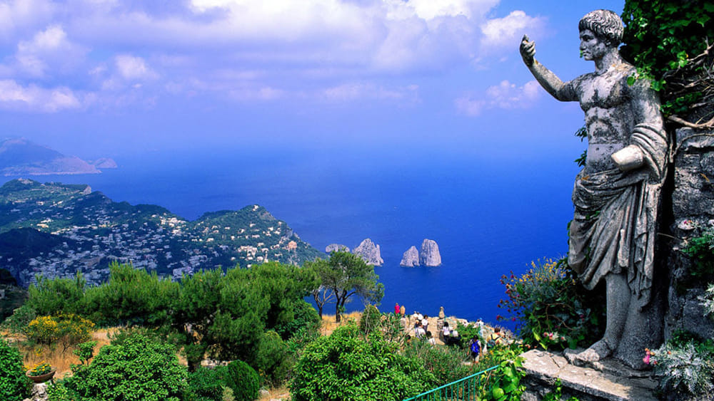

We departure from Fiuggi at 6:30am arriving at the Port of Naples at 9:00a.m. We then depart at 9:30a.m for Capri in a hydrofoil. After arriving in Capri, we will meet with the guide and depart by bus for the island tour. We arrive at Anacapri, a town located on the top of the island, at the foot of Mount Solaro and visit Villa San Michele, the ancient residence of Axel Munthe. The Swedish doctor came to Capri in 1885 and had his residence built on the remains of an ancient chapel dedicated to San Michele. Today the villa is a museum house full of historical finds: sarcophagi, busts, Roman pavements, marbles and columns, and one of the most beautiful Gardens of Italy with plants and flowers from all over the world.Afterwards, weather permitting, we will visit the “GrottaAzzurra” or Blue Grotto (optional visit).We will then continue to the Piazzetta or square of Capri, the lounge of the world and Via Camerelle, the shopping street where you can buy handmade Caprese sandals and Capri's famous perfumes. Via Camerelle leads to the Gardens of Augusto, a set of flowered terraces overlooking the Faraglioni, the famous rock arches in the sea, and the bay of Marina Piccola. We return to the Piazzetta of Capri in the afternoon, on board the characteristic Funicular, in which you will descend for a few minute ride back to the port, you will go back to the hydrofoil for Naples (now scheduled for 5:25p.m). At 6:25 p.m. we will arrive in Naples and return back to Fiuggi by bus where we plan to arrive at approximately 9:00pm.

(***Please note that times may vary due to public transportation used and times are not guaranteed)***

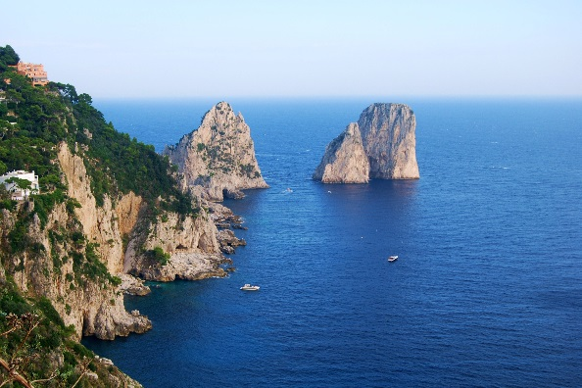

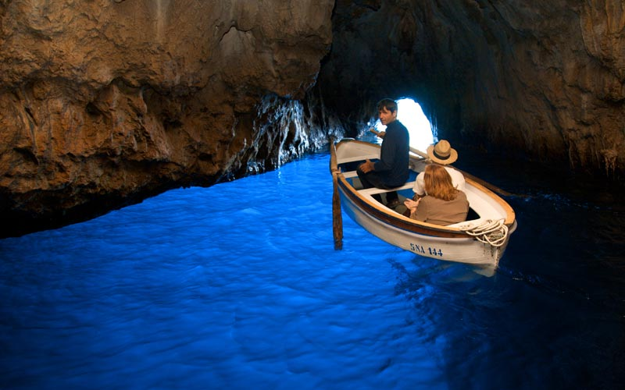

**FIRENZE**

**Wednesday, April 4, 2018**

***€. 269,00 p.p.***

*(€. 30.00 entrance fees not included)*

*Depart: 7:00 a.m. - Return: 9:00 p.m.*

Departure and arrival from hotel in Fiuggi

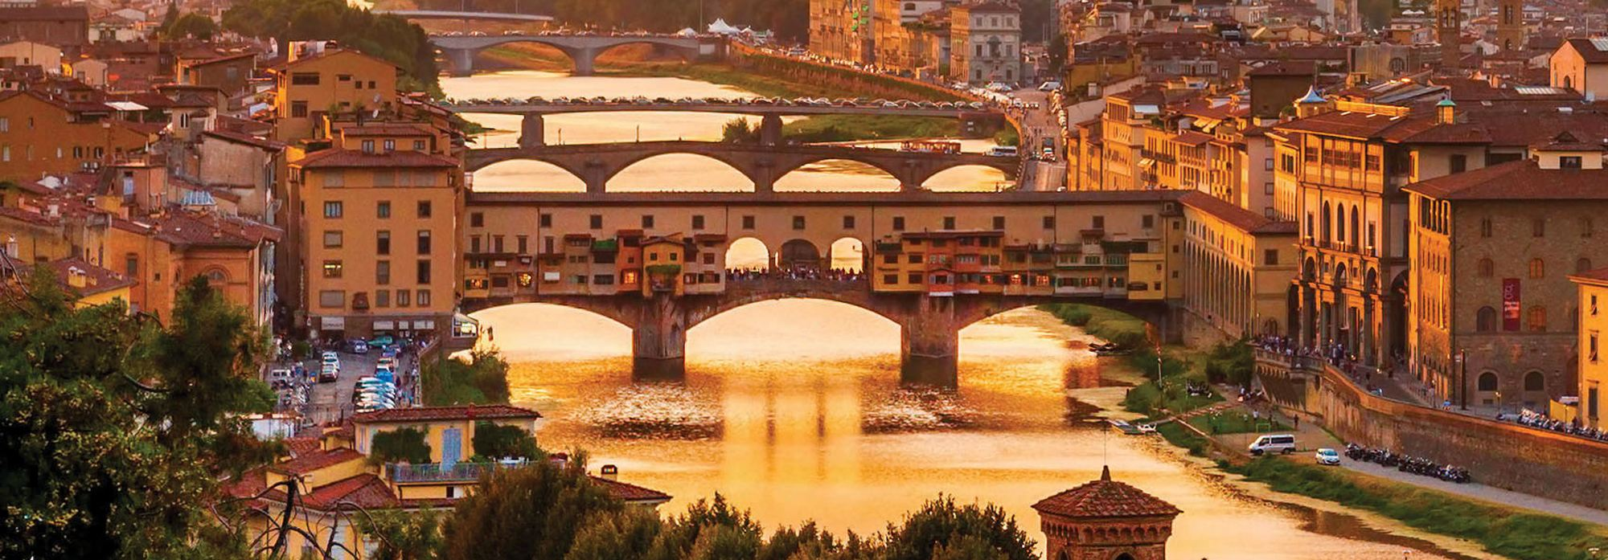

Depart by bus from the hotel at 7:00a.m. to Rome Termini train station. We continue by high velocity train to Florence with an expected arrivalof 10:30a.m. After exiting the Florence train Station, we will be accompanied by an expert guide who will guide us on a 10 minute walk to Piazza del Duomo, one of the most elegant streets of Florence.Here, we can admire the Cathedral of Santa Maria del Fiore, one of the most beautiful and biggest European cathedrals, with its characteristic facade and dome made by Brunelleschi.In front of the Cathedral is the Baptistery of St. John and next to the Duomo, the Bell Tower of Giotto. (This only includes external visits).From Piazza del Duomo, we will continue in Via dei Calzaiuoli to reach Piazza della Signoria. Here you will find the Fountain of Neptune, David of Michelangelo (copy), Palazzo Vecchio and the Loggia deiLanzi.Within walking distance is the Galleria degli Uffizi (Uffizi Museum) where important masterpieces of Italian art are preserved, including many Renaissance works such as "The Birth of Venus" and "Spring" by Botticelli. We will enter the Gallery for a brief guided tour.After a short break for lunch, we will cross Ponte Vecchio, a symbol of the city from which you will be able to observe the old goldsmith shops and jewelry showcases. At the end of the visit, you will return to the train station for your return to Rome, where a reserved bus will take you back to the hotel in Fiuggi.

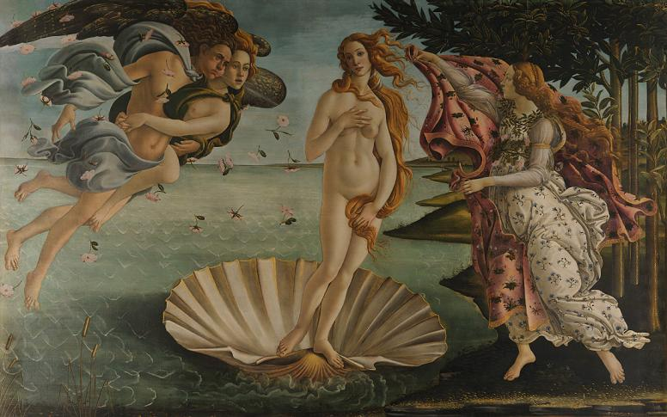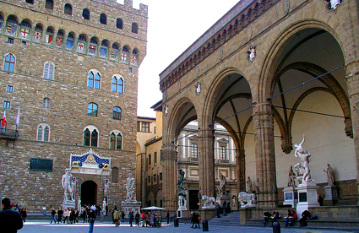

**REGGIA DI CASERTA**

**BORGO DI SAN LEUCIO – MUSEO DELLA SETA**

**Wednesday, April 4, 2018**

***€. 95,00 p.p.***

*(€. 20.00 entrance fees not included)*

*Depart: 8:00 a.m. - return: 5:30 p.m.*

Departure and arrival from hotel in Fiuggi

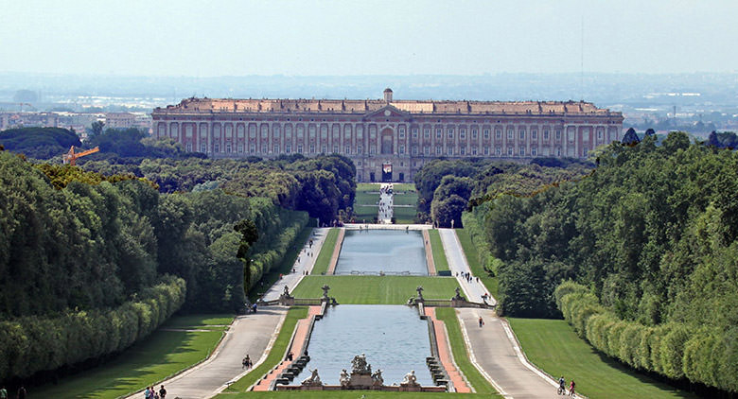

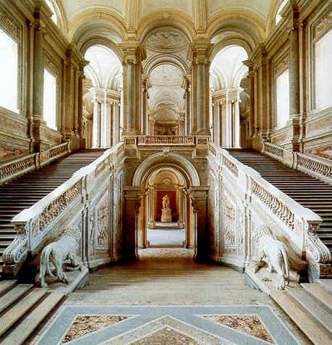The Royal Palace of Caserta was built in 1752 by **LuigiVanvitelli** at the request of the King of Naples, **Carlo di Borbone** or Charles of Bourbon with the purpose to build it as the fulcrum of the new kingdom of Naples and home to the highest level of government, the capital, Naples, and his kingdom. The intent was to build something that could not only stand up to the Palace of Versailles, but even overcome it in majesty. In 1997, The Royal Palace of Caserta was declared a UNESCO World Heritage Site, along with the complex of San Leucio. The Palace consists of an area of 47,000 m2, five floors and four interior courtyards. It has within it a majestic grand staircase, the Palatine Chapel, the historic building, the theatre of the court and the Picture Gallery. The park and the waterfallalso give the complex a highly elegant and scenic view.The visit continues in the village of San Leucio, home of the Silk Museum. Inside, among other things, you will find the school, home of the parish priest, workshops for spinning and twisting silk, the room for weaving and dyeing, the hall of frames and the Royal apartment. In the early 1800’s, work began to make the factory larger with the construction of the Spinning Mill of Cypresses and then, in 1823, the Coculliera for storage and preparation of silk worms waiting for reeling. You will also visit the Royal apartment where you can admire a series of rooms in which silk is the protagonist; the Industrial Archaeology section houses numerous machines and equipment of the era used in the different stages of silk processing and the "House of the Weaver", or rather the typical home of the leuciano worker of the 1800’s. At the end of the tour, you can browse and shop in several of the village shops and take home a piece of this beautiful and famous story from the silk of San Leucio

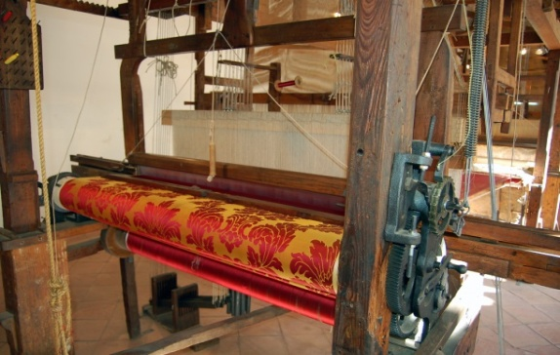

**ANCIENT ROME**

**Colosseum and Roman Forum**

**Thursday, April 5, 2018**

***€. 95,00 p.p.***

*(€. 20.00 entrance fees not included)*

*Depart: 8:30 a.m. - Return: 4:30 p.m.*

Departure and arrival from hotel in Fiuggi

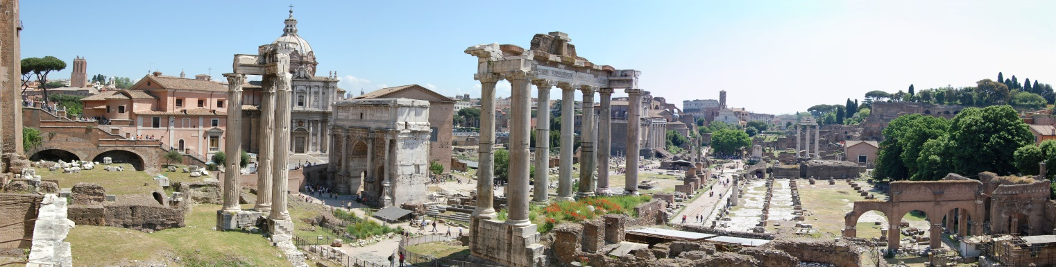

Eternal city, capital of Italy, Roma is also named “caput mundi”. This panoramic tour in the center of the city includes: Stazione Termini, Piazza della Repubblica, Piazza Venezia, Campidoglio, Bocca dellaVerità, Circo Massimo, Colosseo.In the morning, the tour includes visiting the Colosseum and the Roman Forum, after meeting with the guide outside the monument and an initial explanation of the Valley of the Colosseum and the archaeological center.The course is aimed at identifying the main aspects of public life in the heart of the ancient city, from the age of the directing Empire. The careful analysis of the buildings will reveal the functions and all the activities that took place there: the Colosseum, the monumental setting of spectacular fights between gladiators and fairs; the Roman Forum, the centre of judicial, commercial, political and sacral.

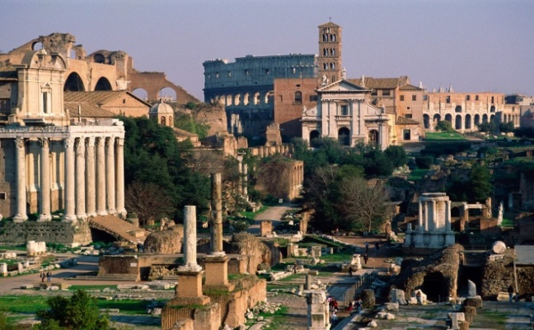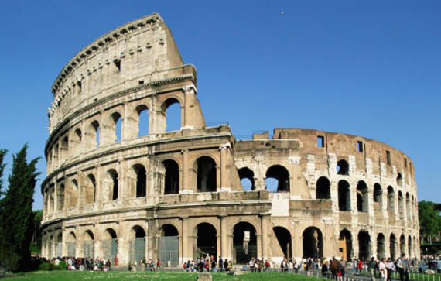

**TIVOLI**

**VILLA D’ESTE AND VILLA ADRIANA**

**Thursday, April 5, 2018**

***€. 95,00 p.p.***

*(€. 20.00 entrance fees not included)*

*Depart: 8:30 a.m. - Return: 5:30 p.m.*

Departure and arrival from hotel in Fiuggi

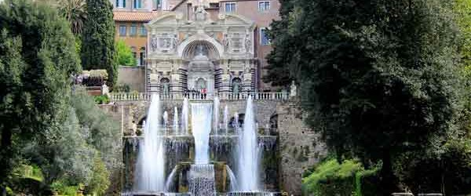

The excursion includes a visit to *Villa D'Este,* a mansion built upon the request of Cardinal Ippolito II D'Este. Life in this villa was a very active one until the mid 1500’s, and was a destination for many famous people. It has some beautiful frescoed halls, but the main attraction consists of it's beautiful and original gardens with numerous fountains of incomparable beauty and majesty. Among these are, the *Fontana dell'Organo, La Rometta*, and *ilVialedelle Cento Fontane,*the pathway with the one hundred fountains and much more.Upon finishing the tour, we transfer by busto Villa Adriana.The Emperor Hadrian built this country villa for himself and his courtand it bears unique testimony to the grandeur and architectural and decorative characteristics of the period. Today it exists as an immense park, extending over 80 hectares and dotted with several Roman ruins as well as spas and houses from the 1700’s, all set in an environment charged with ancient fascination.The grounds also contain the "Teatro Marittimo", an artificial island which was a private residence of the Emperor as well as other interesting sites such as "Canopo", a huge rectangular pool encircled by sculptures which recall the Serapeo. Ongoing excavations have brought to light an intricate system of roads which lead to the imperial residence.

