Marble Quarries and Carrara – Private Tour by 4x4 jeep (Half Day)
Maximum 8 people
Meeting point at 8:45 am and departure at 9:00 am.
Arrival in Carrara expected at about 9:30 am (About 30 mins of travel).

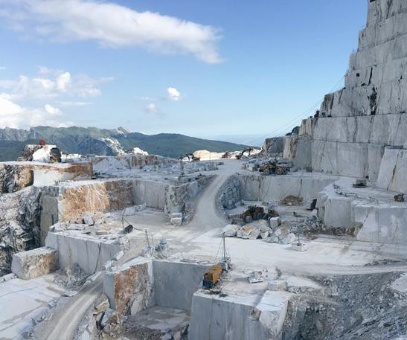
Pick up at the hotel with a 4x4 jeep which will take you on a discovery tour around the the most famous marble basins: Fantiscritti, Miseglia and Torano.

The adventure will start from the moment you step on the
Land Rover Defender . Several
Stops for taking pictures are planned along the way to admire the wonderful views offered by the quarries; the jeep tour will reach 1000 meters above sea level.

The history and techniques of extraction and transporting marble, from the Romans to nowadays, will be explained. The guide will tell you facinating anecdotes about the Marble Civilization: because the world of the white treasure is not only about the extraction or the processing of stones, but includes the very history of the territory and its people, who have always been a synonym of marble.

Three hours of discovering in this magical place where Michelangelo found the block that gave birth to his famous Pietà.

Afterwards it will be possible to take a walk through the small streets of the tiny village of Colonnata.

End of the activity at about 1:30 pm.

Cost of the jeep with guide for max 8 people: euro 700

Gulf of the Poets and Portovenere – Private Tour in Yacht (Full day or half day)

Meeting point at 9:15 pm and departure at 9:30 pm.
Arrival in Portovenere expected at about 10:00 am (About 30 mins of travel). Arrival of the participants in Fiumaretta by private transfer.
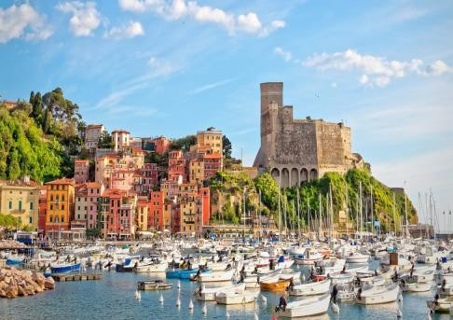
We will start with a moderate sailing trip heading toward Monte Marcello and the first picturesque bays in the area.

Then we will pass by Lerici, a medieval
village dominated by the Castle of San Giorgio.

Afterwards we will discover the archipelago consisting of the islands of Palmaria, Tino and Tinetto; these islands have been included as UNESCO World Heritage Sites.

The final destination will be Portovenere; the boat will stop in front of the oldest and most spectacular part of the village, the splendid Church of San Pietro, built in the 13th century.

The deep gulf that connects Lerici and Portovenere is now called the Gulf of the Poets, because in past centuries these wonderful medieval villages were a source of inspiration for poets,
novelists, painters, and journalists such as Byron, Percy and Mary Shelley, and Virginia Wolf....

Stops for swimming, a dip in the sea or simply relax sunbathing are available during the sailing.

Packed lunch

Disembarkation expected at about 5:00 pm. Return to the hotel by private transfer.
Our fleet consists of yachts of different sizes and comfort, ask for a customized offer:
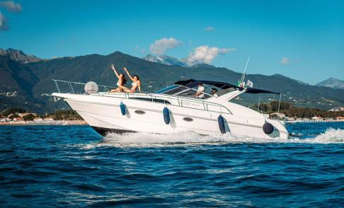
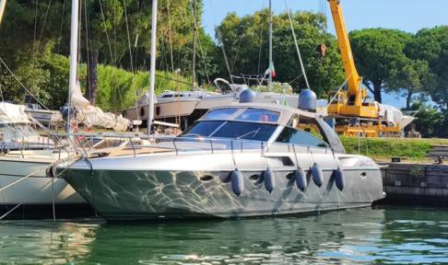

RIO 950 CRUISER, 11 METERS RIZZARDI 48, 16 METERS
Maximum 8 guests Maximum 10 guests
euro 1.800 euro 2.900

Shopping at "The Mall Luxury Outlet Florence" (full day)

Meeting point at 8:45 am and departure at 9:00 am.
Arrival at the Shopping Centre expected at about 10:30 am (About 1:30h of travel).

Where shopping and beauty meet. The exclusive luxury mall in the heart of Tuscany!

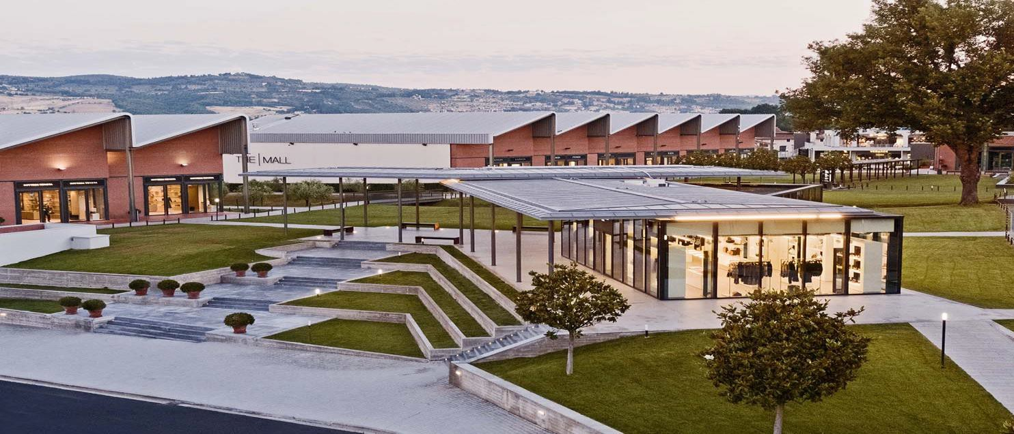

The Mall Florence was born from the research of beauty in all its forms. A special and unique
place to experience fashion counting on affordable prices without sacrificing the highest quality. The perfect mix of elegance and contemporary style makes The Mall Florence a "must visit," and a unique place that makes you fall in love and wish to come back.
You will have the opportunity to visit the Boutiques of the most prestigious Italian fashion brands: Dolce and Gabbana, Gucci, Armani, Ferragamo, Valentino, Tod's, Fendi, Dior, and many others...

Return to hotel at 4:30 pm. Arrival expected at about 6 pm. Private car for max 7 people euro 750

Drive the vintage Fiat 500 (Half day experience)

Meeting point at 9:15 am and departure at 9:30 am.
Arrival in Portovenere expected at about 10:15 am (Abou 40 mins of travel).

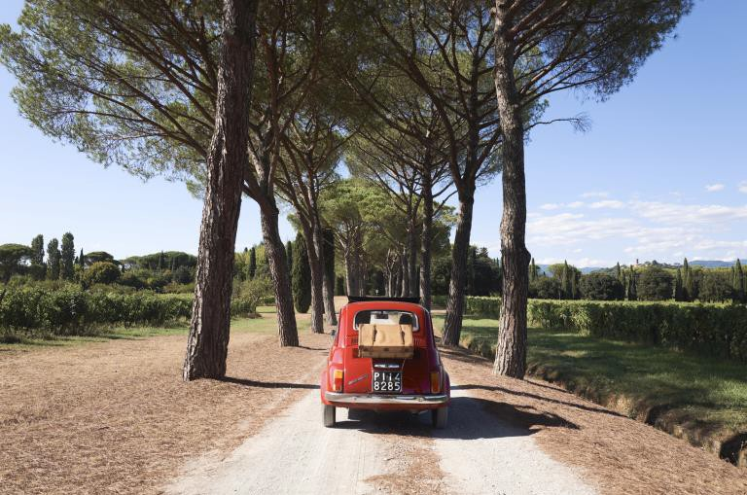
Hardly any other car has become more iconic as the Cinquecento: it is an undeniable symbol of Italy. It represents the Italian style, the dolce vita, the “daughter” of the economic miracle and, despite its age, its charm remains the same. With us, you can rent this classic Italian city car that will take you to the discovery of the Tuscan landscapes, surrounded by the Lucca countryside. Our car fleet made of vintage Fiat 500s, totally restored and maintained with attention to the smallest detail, is available for rent.

Tour “Lucca Country & Montecarlo”
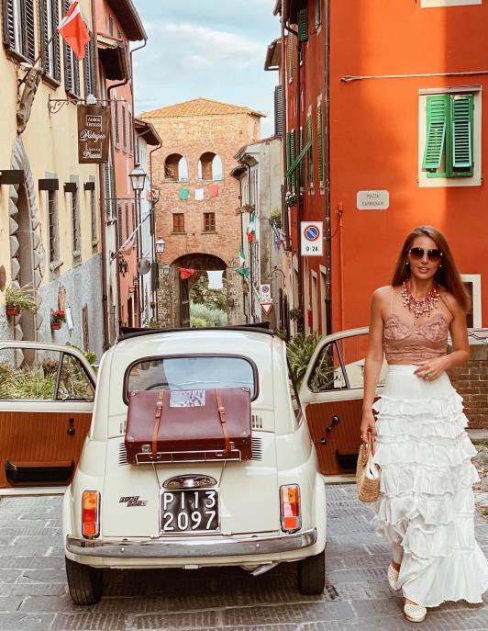
Meeting with your expert guide and sit behind the wheel of a vintage Fiat 500, travel back in time!! You will leave from Lucca and arrive at the village of
Montecarlo di Lucca. It will be a very suggestive
itinerary surrounded by olive trees and picturesque vineyards. You will leave from Lucca and you will drive through the countryside of Lucca reaching as first stop the village of Sant’Andrea di Compito, known as the village of the Camellias. After a short stop at the famous “Garden of the Camellias” in Italy, you will leave for Montecarlo, a picturesque medieval village beautifully preserved. Born around 1933 at the behest of Emperor Charles IV, as a
fortified outpost in defense of Lucca from the Florentine army. Today this beautiful village is the scene of culture, history and a very interesting food and wine tradition! It is here that you will stop to visit this enchanted village.
End of tour at about 1:30 pm
Return to the hotel at about 2:15 pm
Cost for private “Lucca Country & Montecarlo Tour” 1 private minivan with driver for transfer from hotel to Lucca city and back
1 Fiat 500 with expert guide to accompany the group 1 Fiat 500 for 2 guest including fuel and insurance Euro 750
Extra Fiat 500 car for 2 guests euro 320

PRIVATE TOURS IN MAJOR ITALIAN CITIES
Florence (departure at 9 am, return to hotel at 6 pm) Private car for max 7 people starting from euro 750 Milan (departure at 8 am, return to hotel at 8 pm) Private car for max 7 people starting from euro 1.450 Rome (departure at 6 am, return to hotel at 8 pm) Private car for max 7 people starting from euro 1.650 Venice (departure at 6 a.m., return to hotel at 8 pm) Private car for max 7 people starting from euro 1.650 Other destinations on request

We have the possibility to personalize each of your experiences with the presence of a tour guide who speaks your language; we can book entrance fees to Museums and Exhibitions, etc.

