OCTOBER 2, 2023
Gulf of the Poets and Portovenere – Group Tour by Coach + Schooner
Meeting point at 8.15 am. and departure at 8.30 am.
Arrival in Portovenere at about 9:30 am. (About 1h of travel)

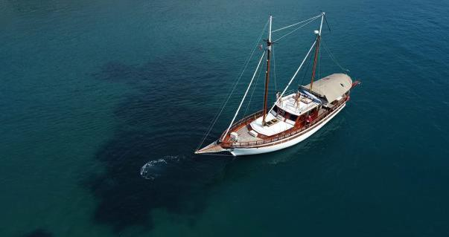
The group will be divided into two groups, the first will go on board of our Caique; we will discover the deep gulf that
connects Lerici, a medieval village dominated by the Castle of San Giorgio, and Portovenere, which today is called the Gulf of the Poets because in past centuries these marvellous
medieval villages were source of inspiration for poets, novelists, painters, and journalists such as Byron, Percy and Mary Shelley, Virginia Wolf.....

Afterwards we will head towards the archipelago which involves the islands of Palmaria, Tino and
Tinetto; these islands are included as UNESCO World Heritage Sites.

Then we will return to Portovenere, coasting the oldest and most spectacular part of the village, the splendid Church of San Pietro, built in the 13th century, which frames the evocative Grotta di Byron.

At the same time the second group (10.00 am - 1.00 pm)
will explore the characteristic village of Portovenere, with its typical colourful tower houses, with a local guide. In addition, we will visit Palazzata a mare, Porta del Borgo and the historic centre, Doria Castle and Byron's Grotto.

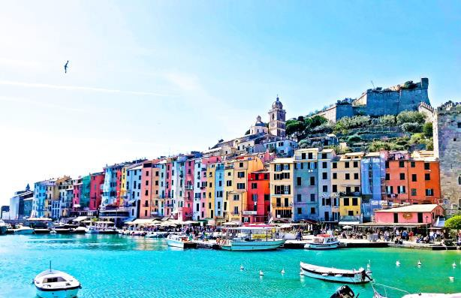
Packed Lunch
In the afternoon the groups will be switched (2:00 pm – 5:30 pm)

Return at about 5:30 pm and arrival at the hotel at about 6:30 pm.

Cost per person euro 150 (Minimum 25 people required)

OCTOBER 3, 2023

Florence – Group tour by Coach with local guide

Meeting point at 8:15 am and departure at 8:30 am.
Arrival in Florence ecpected at about 10:15 am (About 1:40h of travel).

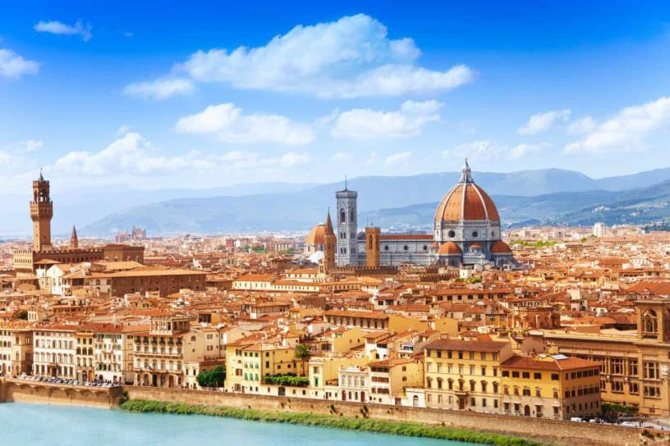

MORNING

- Cathedral of S.Maria Novella
- Cathedral of S.Lorenzo
- Medici Palace
- David
- Duomo
- Brunelleschi's Dome
- Opera of Duomo of Florence’s Museum
- Synagogue and Jewish Museum of Florence
- Strozzi Palace
- Old Palace
- Signoria’ Square
- Old Bridge

Packed lunch

AFTERNOON

- Uffizi Gallery
- Brancacci’s Chapel
- Piazzale Michelangelo
- S.Croce’ Square
- Boboli Garden
- San Miniato al Monte

Return at 4:30 pm and arrival at the hotel at about 6:15 pm. Cost per person euro 90 (Minimum 25 people required)

OCTOBER 4, 2023

Marble Quarries and Carrara – Group tour by Coach (Half day)

On board of a comfortable GT coach, we will travel the road that winds like a snake to the top of the mountain and reach the heart of the marble basins.

We will visit a closed quarry that is still active;
during the tour, the immense rooms of the "Cathedral of Marble" will be shown and there will be given information regarding the birth of the tunnel quarry, the machinery and its uses, the extraction techniques and, of course, information about marble as a material used in various
fields. It will also be possible to admire Ozmo's Mural re-enacting Michelangelo's Genesis. At the end of the closed quarry tour, it will be possible to visit the open-air Marble Museum.
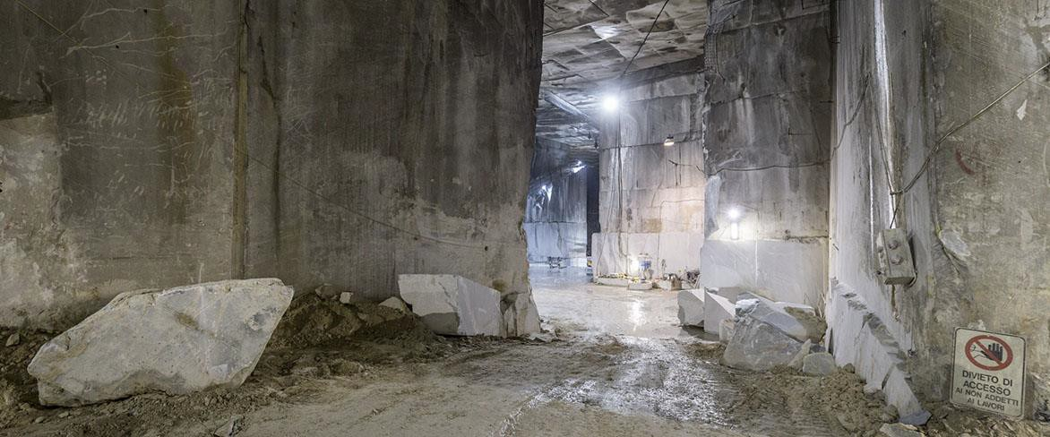

Afterwards it would be possible to have a nice walk around the tiny streets of the peculiar village of Colonnata.

Cost per person euro 90 (Minimum 25 people required)

MORNING TOUR
Meeting point 8:45 am and departure 9:00 am.
Arrival in Carrara expected at about 9:30 am (About 30 min of travel). Return to the hotel at 1:00 pm.

AFTERNOON TOUR
Meeting point 1:45 pm and departure 2 pm.
Arrival in Carrara expected at about 2:30 pm (About 30 min of travel). Return to hotel at 6 pm.

OCTOBER 5, 2023

San Gimignano and Siena - group tour by Coach with local guide

Meeting point at 8:15 am and departure at 8:30 am.
Arrival in San Gimignano expected at about 10:15 am (About 1:40h of travel).
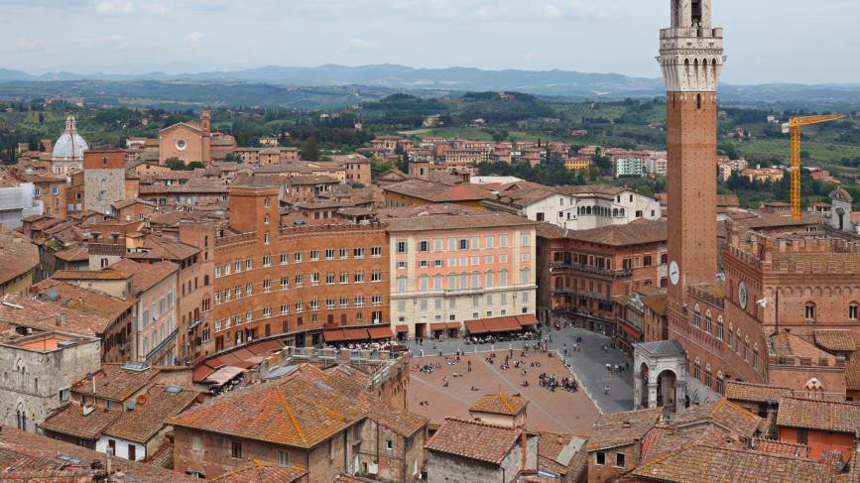

MORNING SAN GIMIGNANO (1h/1:30h of visit)

- S.Agostino Church
- Rocca Montestaffoli
- Collegiata of S.Maria Assunta
- Duomo Square
- Towers
- Gagliardi Gallery
- Panoramic view

Departure to Siena at 11:30 am and arrival at abour 12:30 am. (About 1h of travel).

Packed Lunch

AFTERNOON SIENA

- Piazza del Campo
- Bothanical garden
- Panoramic view
- Towers
- Fortezza Medicea
- National Pinacoteca
- Piazza del Duomo
- Sinagogue
- Vestri Palace
- Libreria Piccolomini (Duomo)

Return at 4:30 pm and arrival at the hotel at about 7:00 pm. Cost per person euro 90 (Minimun 25 people required) Possibility of tour by car and private guide ON REQUEST

OCTOBER 6, 2023

Cinque Terre – Group tour by train with local guide

Meeting point at 9:15 am and departure at 9:30 am. Transfer to Forte dei Marmi station and departure by train.
Arrival to the first village expected at about 10:30 am (About 1h travel).
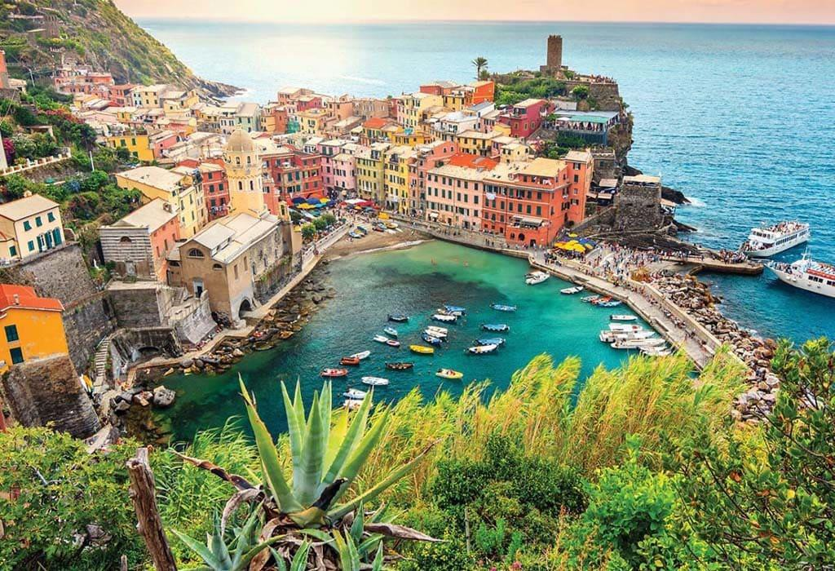

Our local guide will accompany you to the heart of the Cinque Terre:
Monterosso, the biggest of the five villages, the only one with a beautiful fine sandy beach. Vernazza, the most beautiful and characteristic, with a pretty little port and a charming church in front of the small bay.
Riomaggiore, with its typical tower houses.
Manarola, the oldest of the villages where the colorful facades of the houses stand out against the black rocks on which they stand.
Corniglia, the only one that has no direct access to the sea but gives the most spectacular view
of the coast.
It will be pleasant to walk through the five villages and listen to the anecdotes and curiosities of this area now known worldwide for its priceless beauty.

Packed lunch

Return at 5:00 pm and arrival at the hotel at about 7:00 pm. Cost per person euro 100 (Minimum25 people required) Possibility of tour with private guide ON REQUEST

OCTOBER 6, 2023

Lucca and Pisa – Group tour by Coach with local guide

Meeting point at 8:15 am and departure at 8:30 am.
Arrival in Lucca expected at about 9:15 am (About 40 mins of travel).

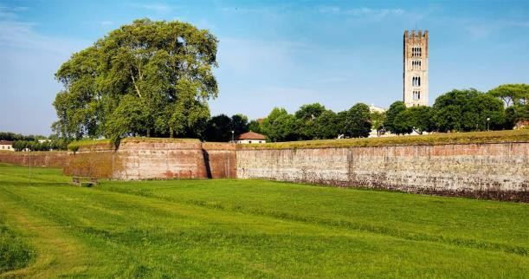
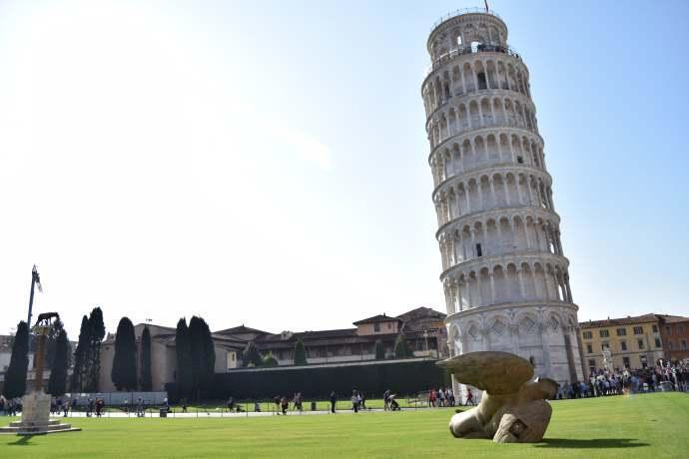

MORNING LUCCA (3h)

- Walk around the walls of Lucca - Pfaffer Palace and its portals - Torre delle ore
- Palazzo Ducale - Museum of Puccini’s House
- Cathedral Museum - Palazzo Mansi Museum
- Bothanical Garden - Napoleone’ Square
- S.Michele Church - Villa Guinigi Natiola Museum
- Domus Romana - Villa Torrigiani

Packed lunch

Departure to Pisa at 1:00 pm and arrival expected at about 1:45 pm (About 40 mins of travel).

AFTERNOON PISA (4h)

- Piazza dei Miracoli - Sinaogue
- Walls - S.Matteo Museum
- Santa Maria Street - Palazzo Blu
- Bothanical Garden - Corso Italia
- Piazza dei Cavalieri - Vittorio Veneto’ Square
- Lungarni - S.Maria della Spina Church

Return at 6:00 pm and arrival at the hotel at about 6:45 pm (About 40 mins of travel). Cost per person euro 90 (Minimum 25 people required)

Possibility of tour by car and private guide ON REQUEST

